**Lab 9**

**MongoDB Tutorial for Beginners:** [**https://beginnersbook.com/2017/09/mongodb-tutorial/**](https://beginnersbook.com/2017/09/mongodb-tutorial/)

**MongoDB Online Terminal:**

[**https://www.jdatalab.com/mongodb/**](https://www.jdatalab.com/mongodb/)

**Type the commands and insert screen shots. Each question is worth 2 pts.**

1. **Create a database called Restaurant**

**use Restaurant**

1. **Insert the following documents into the database.**

name: "ABC Bake Shop",

address: “1007 Morris Park Ave”,

zipcode: 11225,

cuisine: “Bakery”,

grade: “A”,

rest_id: 3007

name: "Mikes Deli",

address: "9825 Angry Ave",

zipcode: 11226,

cuisine: "Deli",

grade: "B",

rest_id: 3008

**3. Show all documents in the database.**

**db.locations.find().pretty()**

1. **Load the provided json file to your database.**

**var file = cat("./rest6(1).json");**

**var o = JSON.parse(file);**

**db.locations.insert(o);**

1. **Find the following documents in the database.**

**"cuisine": "Bakery"**

**db.locations.find({cuisine:"Bakery"}).pretty()**

**"grade": "B"**

**db.locations.find({grade:"B"}).pretty()**

**"restaurant_id": > "3007"**

**db.locations.find({restaurant_id:{$gt:3007}}).pretty()**

**“name” with Bake in the name.**

**db.locations.find({name: /Bake/}).pretty()**

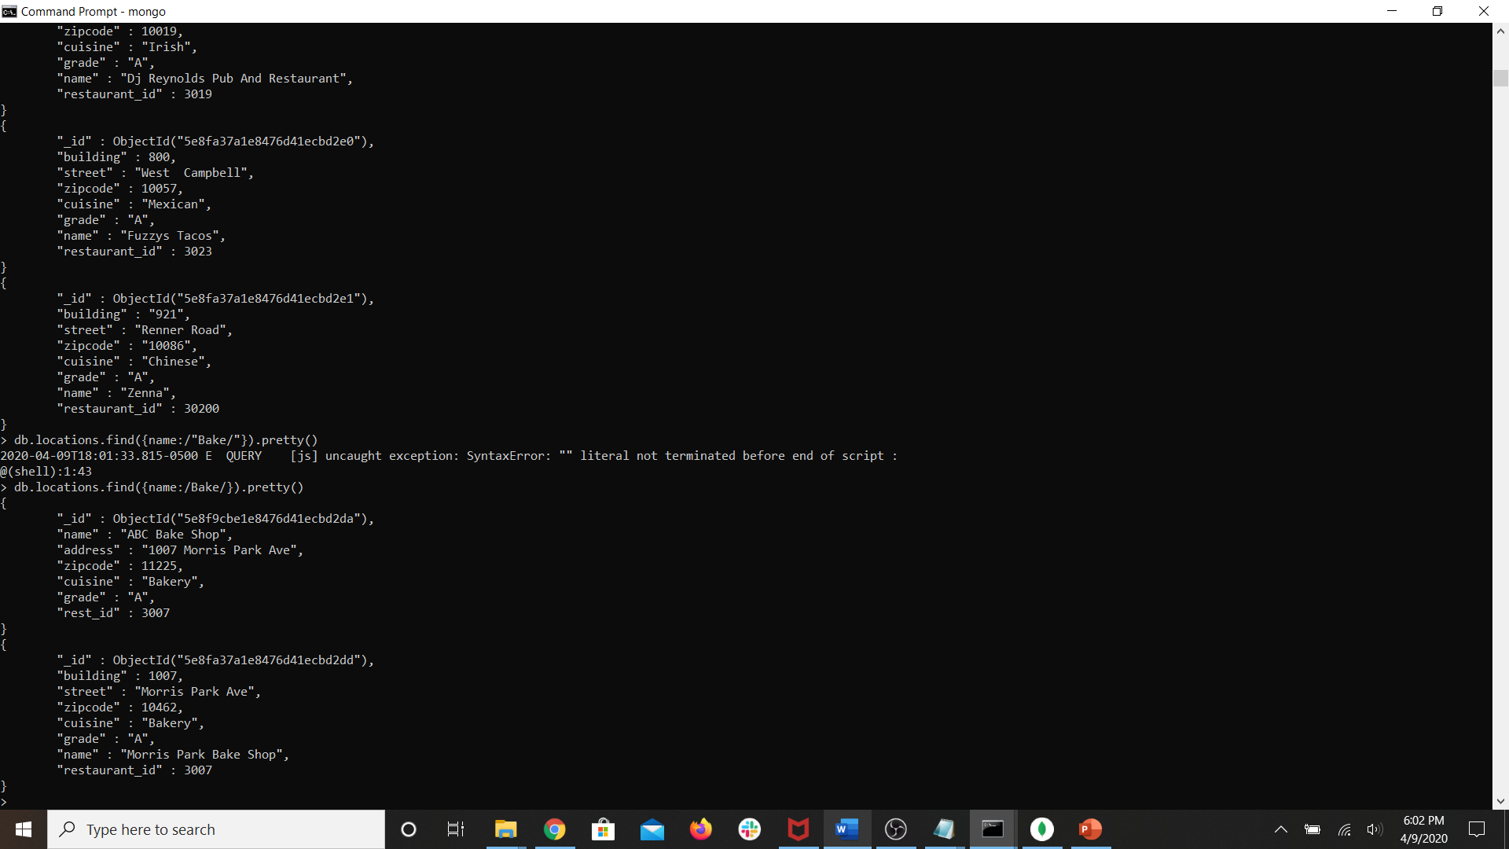

**$gt, $lt, $ne, / /**